**OBJECT ORIENTED PROGRAMMING LABORATORY WORK**

**MODULE 5**



**CREATED BY :**

**KURNIAWAN BAGASKARA**

**L200214253**

**INFORMATICS STUDY PROGRAM**

**FACULTY OF COMMUNICATION AND INFORMATION SCIENCE**

**MUHAMMADIYAH SURAKARTA UNIVERSITY**

**Exercise 1**

**Creates a class containing name, nim, and address and a default constructor that can return name, nim, and address. Next create a new class with the main() function in it to display the results.**

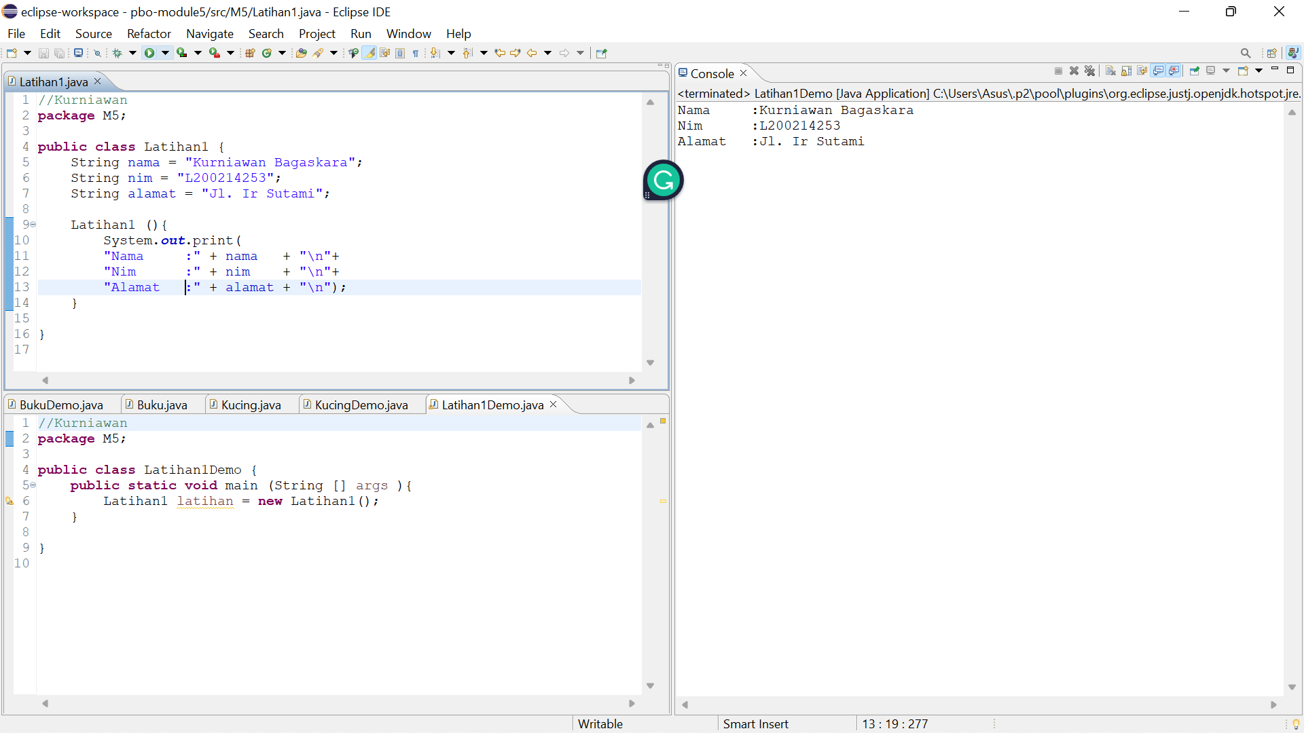

**Exercise 2**

**Create a Book class with String variables AuthorName, String Book title, int**

**year of issue, int print to and double the selling price. Next create three constructors**

**with different parameters, as well as a method to display the book's information.**

**Create 10 book objects with the main() function that can display the values ​of all the Book parameters.**

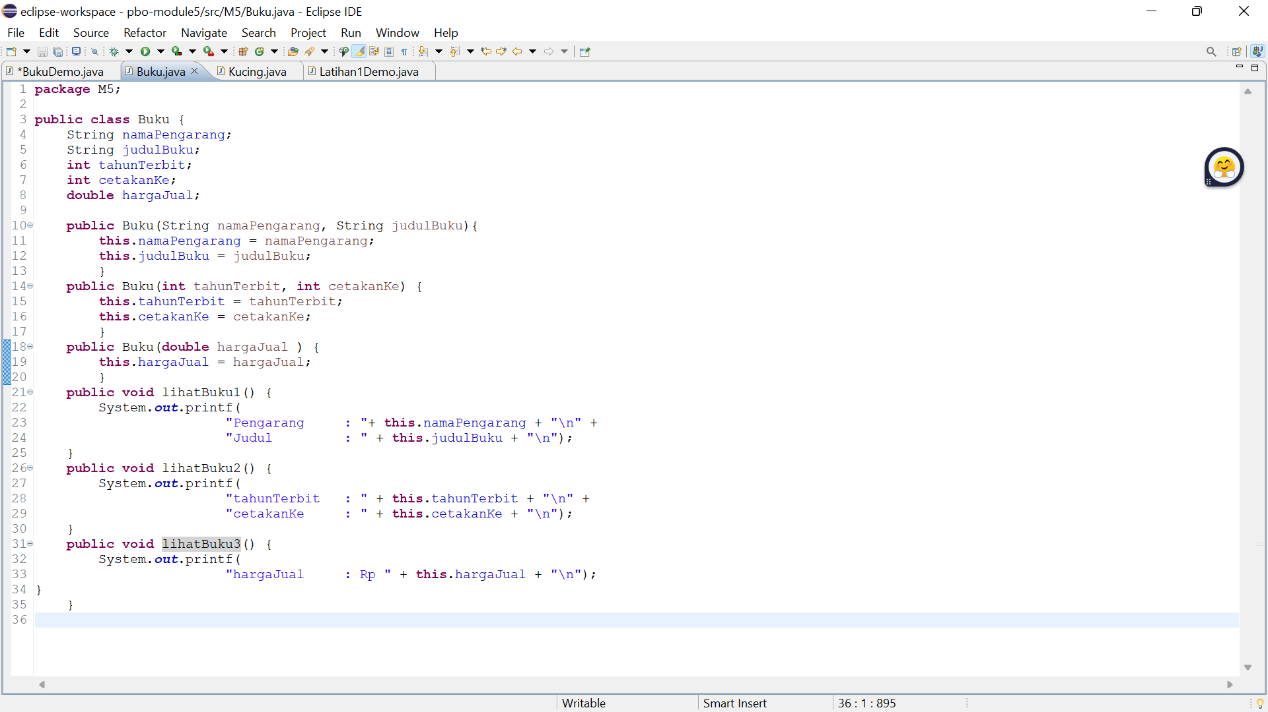

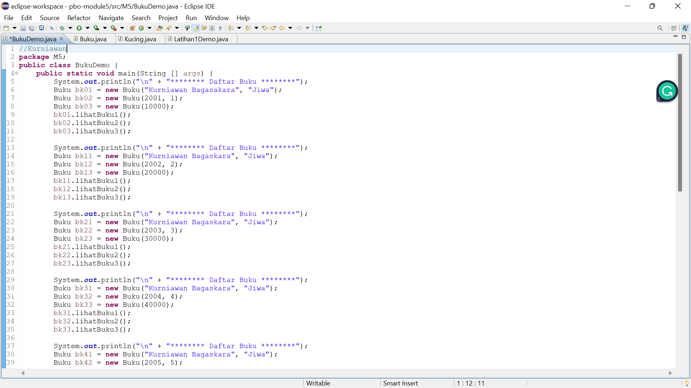

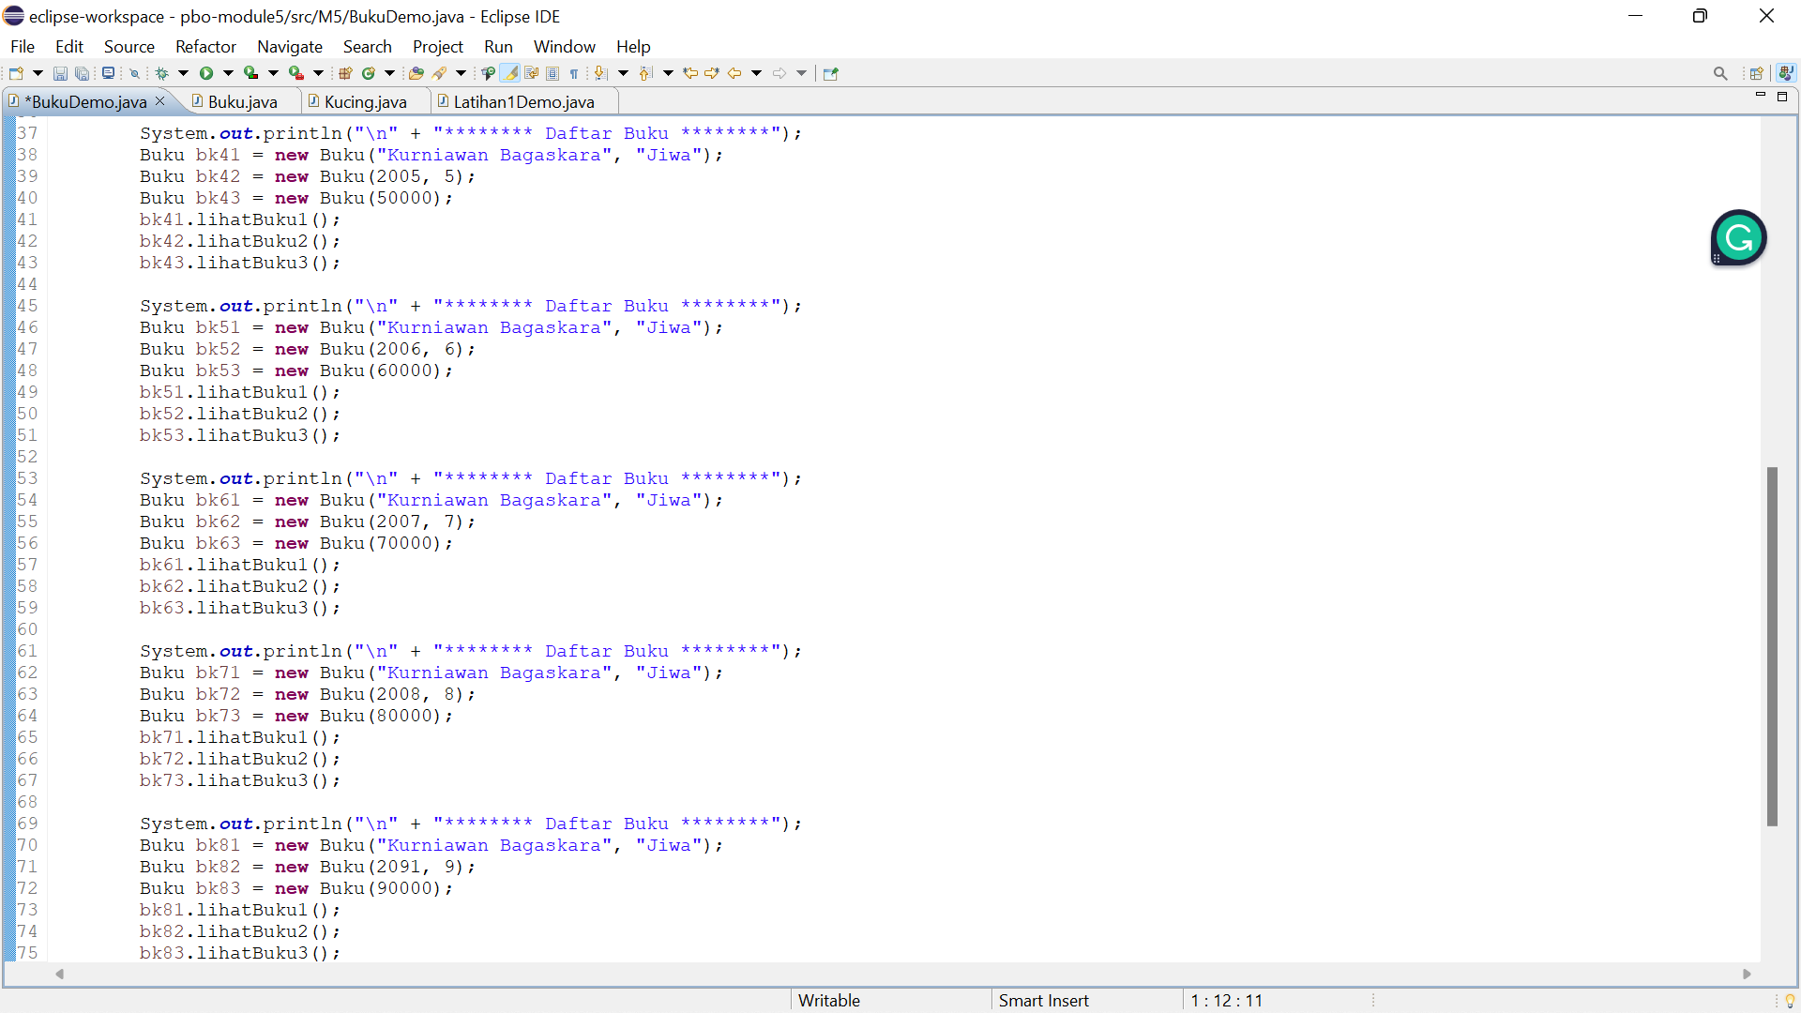

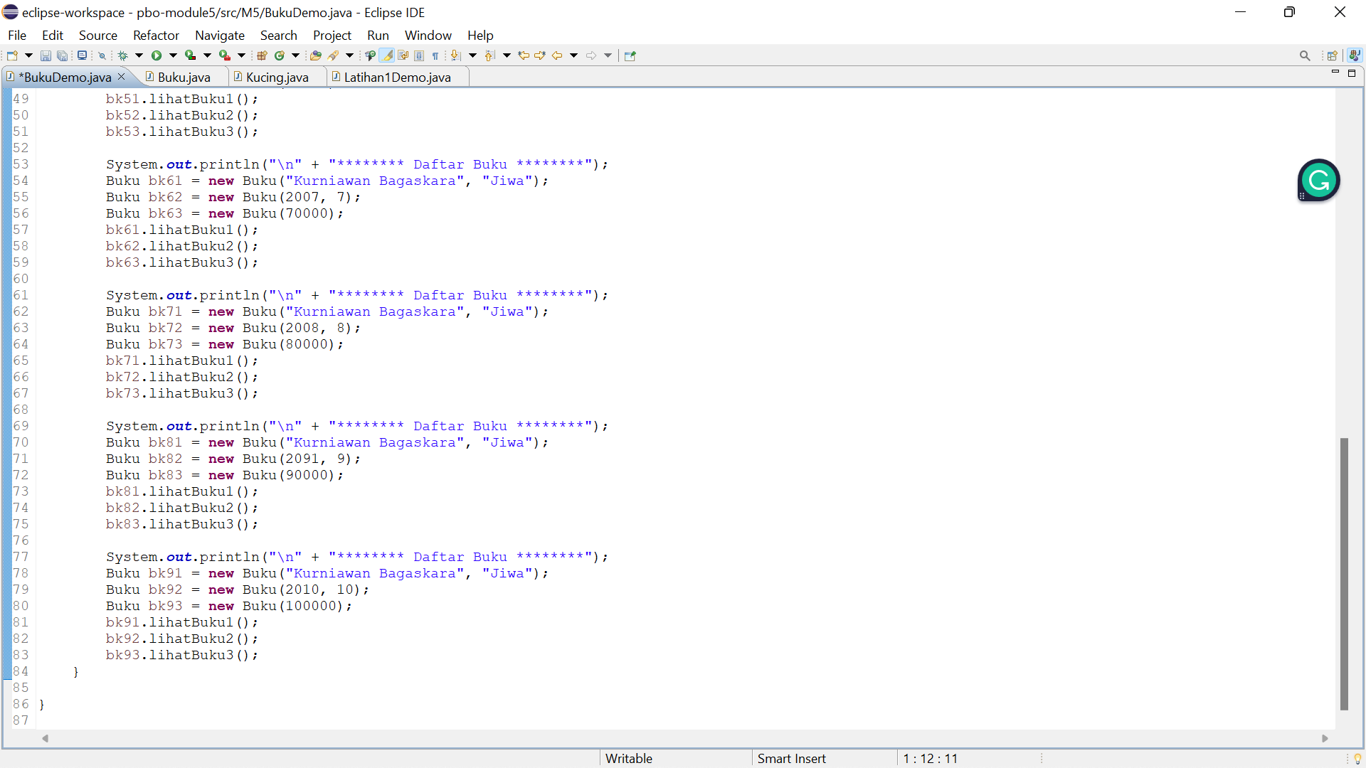

Output:

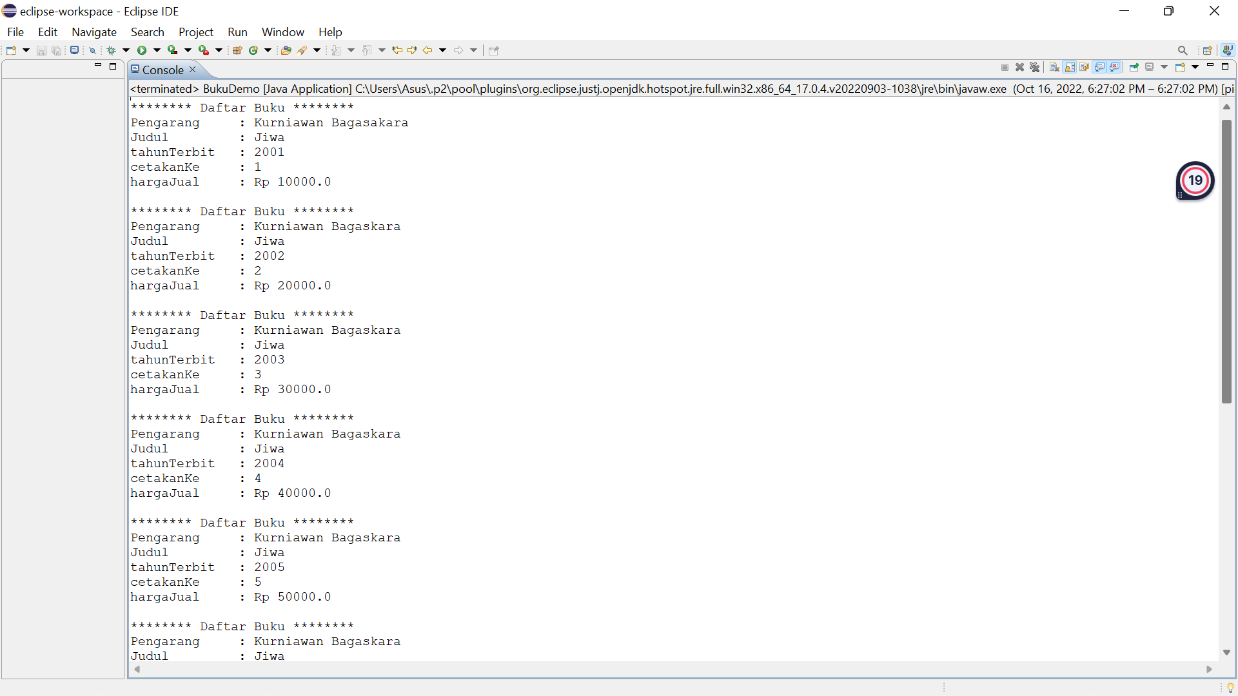

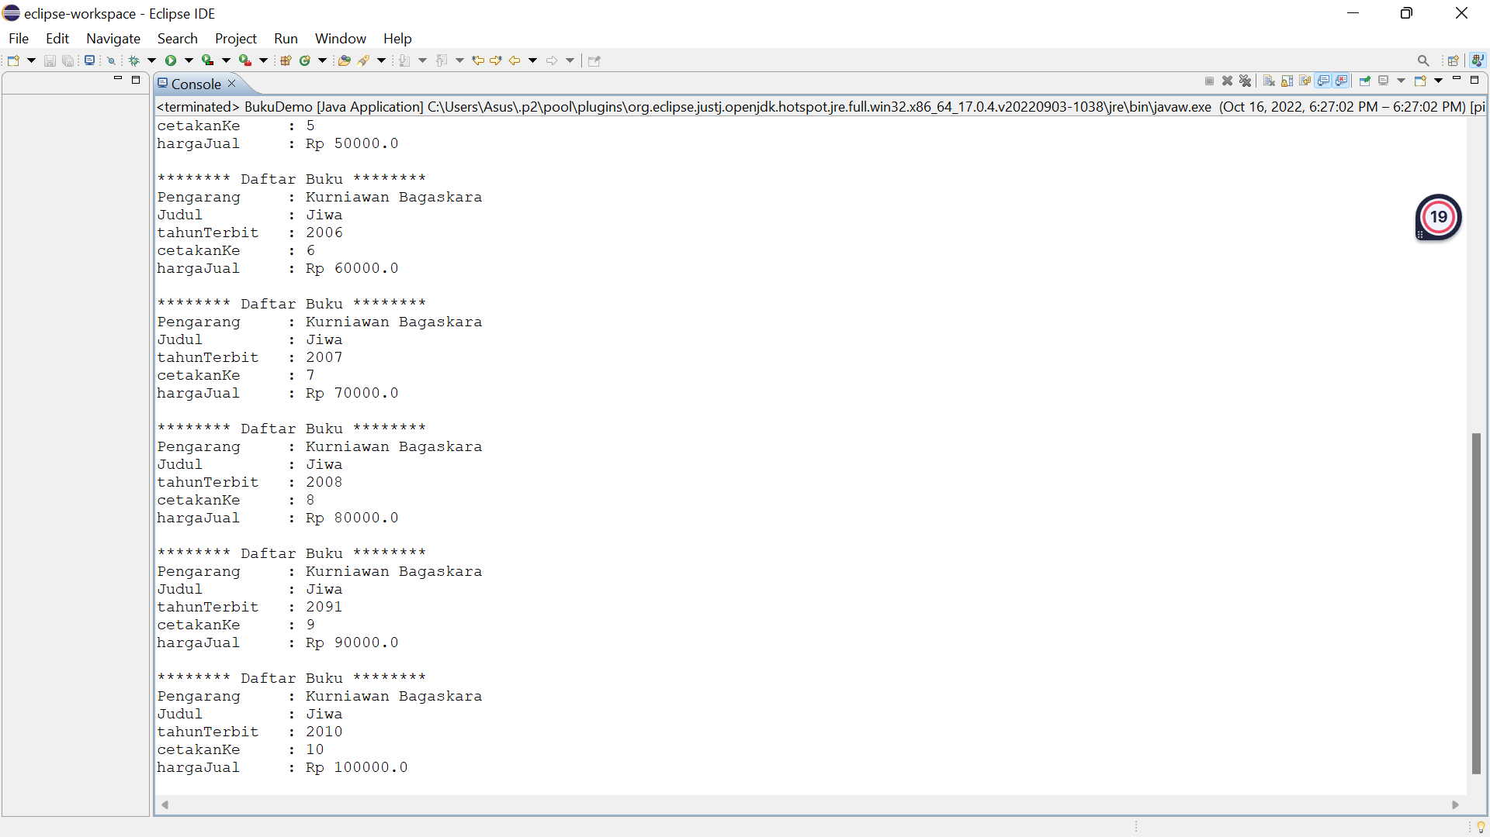

**Task**

1. **Creating a class that contains a default constructor and a parameterized constructor.**
2. **Added a new class containing the main() method as an implementation of the class**

